Fleetman Live Tracking
Pre-requisite
Login to dockerhub in browser
Click on Explore > Images > virtualpairprogrammers/fleetman-webapp > copy docker pull cmd >
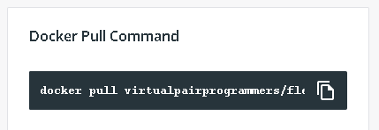

- Create a file
- mkdir dell
- cd dell
- docker pull virtualpairprogrammers/fleetman-webapp

- docker container run -p 9999:8080 virtualpairprogrammers/fleetman-webapp
- History
Open browser
Search <ip address>:9999
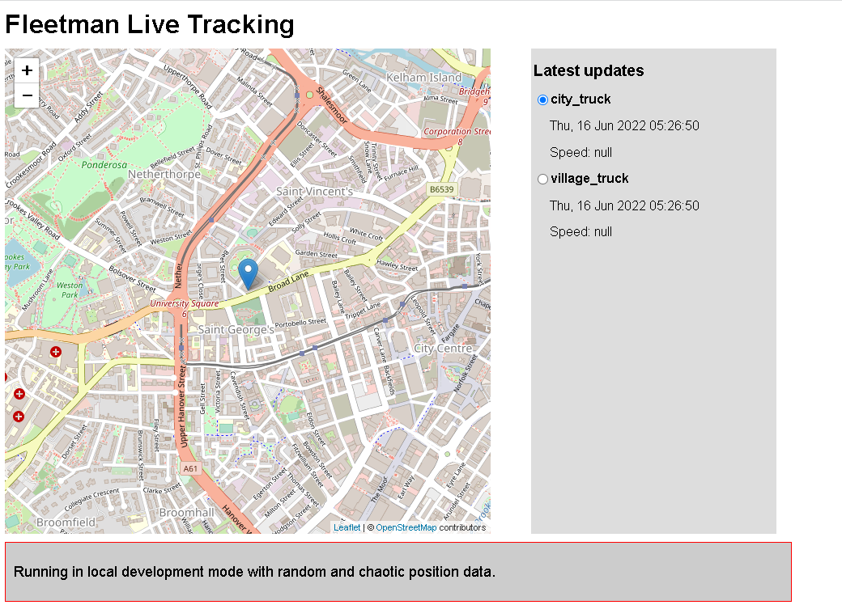
Imp cmds

>docker container list
It shows running containers
>docker container stop <conatiner id>
Stop does not means to remove the container
>docker container list -a
It shows also not running containers
>docker container prune
It will remove all stop containers Press Y/N

NOTE:
run ⇒ start
stop⇒ stop will not remove
prune ⇒ remove all stopped cointainers
rm⇒ remove specific container
Eg :
Docker image rm tomcat
Docker image rm tomcat

If you want to delete every thing
1.stop
2.prune
3.docker image rm <name>
4.docker container rm <name>

—-------------------------------------------------------------------------------------
Creating a Web application

Web application options:
- Java: JSP/Servlets on Tomcat/ngnx
- Python: Flask/Django
- JavaScript: node.js, express.js, angular, react
- PHP/.NET
—-------------------------------------------------------------------------------------
Create a file
Under that create a python web application with .py extension
from flask import Flask

helloflask = Flask(__name__)
@helloflask.route("/")

def run():
return "{\message\":\"Hello Flask version 2!\"}"
if __name__ == "__main__":
helloflask.run(host="0.0.0.0", port=int("5000"),debug=True)

Create a Dockerfile with same name
From python:alpine3.10
WORKDIR /app
COPY . /app
RUN pip install -r requirements.txt
EXPOSE 5000
CMD python ./hello_flask.py

#COPY requirements.txt /app/requirements.txt
#ENTRYPOINT ["python", "./hello_flask.py"]

Create requirement.txt
On cmd
echo "flask" > requirements.txt

Run cmd
#docker build -t hello_flask .
#docker run -d -p 5000:5000 hello_flask
(python file name i.e hello_flask.py)

Open browser
Search 192.168.80.129:5000
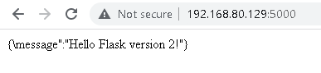
—--------------------------------------------------------------------------------------

How to update the version of the webapplication

On cmd inside same folder

docker build -t "hello-flask:0.0.1.RELEASE" .
docker build -t "hello-flask:0.0.2.RELEASE" .
docker run -d -p 5006:5000 "hello_flask:0.0.2.RELEASE"
Open browser
<ipaddress>:5006
NOTE:
Make changes in python code make version1 to version2 in the message

